**Sequence of Events for DMS-issue:- #INC3084845**

* Traffic failover for below URL’s
* kyc-ws.prod.wudip.com (wupos)  
  dmsmodelbretrieval.prod.wudip.com(wupos)  
  dmsiwatch.prod.wudip.com(iwatch)  
  dmsdocupload-prd.wuintranet.net (pharos upload)  
  dmsdocretrieval-prd.wuintranet.net(pharos retrieval)  
    
  Switch requested @6:31 PM IST  
  Traffic switched for above URL's from CHICAGO- to RESTON-DC @6:37 PM IST,  
  in-spite of traffic switch, issues continues to exist and discussion is ongoing  
  traffic switch back to CHICAGO-DC requested @6:46 PM IST  
  traffic routed back to listed-URL's back to CHICAGO-DC @6:50PM IST  
    
  NOTE:- traffic failover performed only @GTM level  
  Current traffic is back to CHICAGO-DC, the original DC, prior to the issue
* Backed up Model-A configuration**{ /tmp/Backup_emergency_DMS}**
* Model-A file-size was made to “0”, due to issues, change was reverted back
* Backed up Model-B configuration**{ /tmp/ModelB_backup}**
* FileSize value changed to **“0” from “10485760”(** Model-B configuration)
* Changed “Filesize” and “dbaseURL”(Model-A)
* Model-A application was re-started
* “Dbaseuname” and “CYBERARKURL” parameters were changed on chicago-nodes**(ModelA)**
* Model-A application was re-started
* Dbaseuname” and “CYBERARKURL” parameters, were reverted back to previous state**(ModelA)**
* Model-A application was re-started

**Changes reverted back to previous state:-{original config of “dbase” and “cyberark”}**

dbaseuname=prdasia

CYBERARKURL=https://cyberark-ccp.wuintranet.net/AIMWebService/api/Accounts?Folder=Root&AppID=App_DMS_P&Safe=AS_DMS_P&UserName=

* Listed 5-URL’s traffic, moved to RESTON-DC
* Reverted back , “Model-A” and “Model-B” changes from “Original-backup”
* Model-A application was re-started

**Model-A(10.47.16.69):-**

**Model-A(10.47.16.93):-**

**Model-A path:-**

/apps/Websphere9/IBM/WebSphere/AppServer/profiles/AppSrv01/installedApps/WUWCC9ASDMS05Cell01/KYCDMSUploadModelA.ear/KYCDMSUploadModelA_3.0.war/WEB-INF/classes/com/wu/kyc/Resources

Backup-file location:- /tmp/Backup_emergency_DMS

**Model-B path:-**

/apps/Websphere9/IBM/WebSphere/AppServer/profiles/AppSrv01/installedApps/WUWCC9ASDMS05Cell01/KYCDMSUploadModelB.ear/KYCDMSUploadModelB_3.0.war/WEB-INF/classes/com/wu/kyc/Resources

Backup-file location:- /tmp/ModelB_backup

Changes made:-

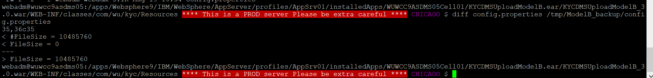

Change-made to accommodate password change:-

